R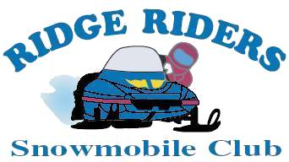 | Ridge Riders Snowmobile Club, Inc.  PO Box 1004 Whitney Point, NY 13862  WWW.RidgeRidersWP.org | 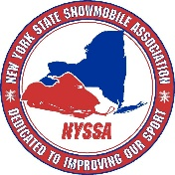
bv
Official Use Only

Date Received ___________

Membership ____ 210+ ____

Total Amt. Paid __________

___ Cash or ___ Check

Check # ____________

Membership Application for 2020 -2021 Season

Below is the current membership information we have for you. Please write in any corrections needed below the item. The Children field is intended for children that are under 18 who intend to register a snowmobile in their name. Your name and address information must match your snowmobile registration information to get a $55 discount on your N.Y. Snowmobile Registration fee. If you have any questions: contact Sue Marsh at Marsh520@aol.com

*** PLEASE PRINT CAREFULLY!!! ***

NYSSA # | Name: |  | Spouse:
Children:
Address: ,
Phone: |  | Email:
Number Of Sleds Registered: |  | Newsletter delivery method (Check One)
 |  | ____ E-Mail ____ USPS Mail ____ Don’t send me one.

Check ONE of the options below: (One Membership fee includes all names listed above.)
____ $30 Membership - Includes a $5 NYSSA (NY State Snowmobile Association) Membership, $1 Sled NY donation, Membership Card, Snowmobile Registration Discount Voucher ($55 value per sled registered) and a one year subscription to the New York Snowmobiler Magazine.

____ $24 Membership - Use this option if you are already a member of another club and will be registered with NYSSA through that club. Registration Discount Voucher will be supplied by that club.
Please enter that club's name here: ______________________________________

($_______) Write in any additional donation to the Ridge Riders Snowmobile Club

We need volunteers to help maintain our trail system. Trails aren’t maintained with money alone. Please put a check mark next to the type of volunteer work you would be willing to help with.

___ Trail Grooming ___ Trail Maintenance ___ Groomer Maintenance
___ Fund Raising ___ Trail Mapping / GPS ___ Web Page (Maintain / Design)
___ Club Officer or Board Member ___ Club Events ___ Land Owner Liaison
___ Other… Explain: _______________________________________________

*** Make Checks payable to: Ridge Riders Snowmobile Club, Inc.

*** Bring application to a club meeting or mail the application to the address at the top of this form

Signature: _________________________________ Date: __________________
(A parent or guardian’s signature is required below, if under 18)

Parent/Guardian ____________________________ Date: __________________

Ridge Riders Snowmobile Club
PO Box 1004
Whitney Point, NY 13862

,

